**MS SQL Coding Challenge- 31.03.2025**

**Car Rental System**

**Name : Harish S**

**Creating database:**

create database carrentalsystem;

use carrentalsystem;

**Creating tables:**

**Vehicle:**

create table vehicle (

vehicleid int primary key identity(1,1),

make varchar(30),

model varchar(30),

year int,

dailyrate decimal(10,2),

status bit,

passengercapacity int,

enginecapacity int

);

**Customer:**

create table customer (

customerid int primary key identity(1,1),

firstname varchar(45),

lastname varchar(45),

email varchar(30) unique,

phonenumber varchar(20)

);

**Lease:**

create table lease (

leaseid int primary key identity(1,1),

vehicleid int foreign key references vehicle(vehicleid),

customerid int foreign key references customer(customerid),

startdate date,

enddate date,

leasetype varchar(10) check (leasetype in ('daily', 'monthly'))

);

**Payment:**

create table payment (

paymentid int primary key identity(1,1),

leaseid int foreign key references lease(leaseid),

paymentdate date,

amount decimal(10,2)

);

**Inserting values into the tables:**

insert into vehicle (make, model, year, dailyrate, status, passengercapacity, enginecapacity) values

('toyota', 'camry', 2022, 50.00, 1, 4, 1450),

('honda', 'civic', 2023, 45.00, 1, 7, 1500),

('ford', 'focus', 2022, 48.00, 0, 4, 1400),

('nissan', 'altima', 2023, 52.00, 1, 7, 1200),

('chevrolet', 'malibu', 2022, 47.00, 1, 4, 1800),

('hyundai', 'sonata', 2023, 49.00, 0, 7, 1400),

('bmw', '3 series', 2023, 60.00, 1, 7, 2499),

('mercedes', 'c-class', 2022, 58.00, 1, 8, 2599),

('audi', 'a4', 2022, 55.00, 0, 4, 2500),

('lexus', 'es', 2023, 54.00, 1, 4, 2500);

insert into customer (firstname, lastname, email, phonenumber) values

('john', 'doe', 'johndoe@example.com', '555-555-5555'),

('jane', 'smith', 'janesmith@example.com', '555-123-4567'),

('robert', 'johnson', 'robert@example.com', '555-789-1234'),

('sarah', 'brown', 'sarah@example.com', '555-456-7890'),

('david', 'lee', 'david@example.com', '555-987-6543'),

('laura', 'hall', 'laura@example.com', '555-234-5678'),

('michael', 'davis', 'michael@example.com', '555-876-5432'),

('emma', 'wilson', 'emma@example.com', '555-432-1098'),

('william', 'taylor', 'william@example.com', '555-321-6547'),

('olivia', 'adams', 'olivia@example.com', '555-765-4321');

insert into lease (vehicleid, customerid, startdate, enddate, leasetype) values

(1, 1, '2023-01-01', '2023-01-05', 'daily'),

(2, 2, '2023-02-15', '2023-02-28', 'monthly'),

(3, 3, '2023-03-10', '2023-03-15', 'daily'),

(4, 4, '2023-04-20', '2023-04-30', 'monthly'),

(5, 5, '2023-05-05', '2023-05-10', 'daily'),

(4, 3, '2023-06-15', '2023-06-30', 'monthly'),

(7, 7, '2023-07-01', '2023-07-10', 'daily'),

(8, 8, '2023-08-12', '2023-08-15', 'monthly'),

(3, 3, '2023-09-07', '2023-09-10', 'daily'),

(10, 10, '2023-10-10', '2023-10-31', 'monthly');

insert into payment (leaseid, paymentdate, amount) values

(1, '2023-01-03', 200.00),

(2, '2023-02-20', 1000.00),

(3, '2023-03-12', 75.00),

(4, '2023-04-25', 900.00),

(5, '2023-05-07', 60.00),

(6, '2023-06-18', 1200.00),

(7, '2023-07-03', 40.00),

(8, '2023-08-14', 1100.00),

(9, '2023-09-09', 80.00),

(10, '2023-10-25', 1500.00);

select * from vehicle;

select * from customer;

select * from lease;

select * from payment;

**1.Update the daily rate for a Mercedes car to 68.**

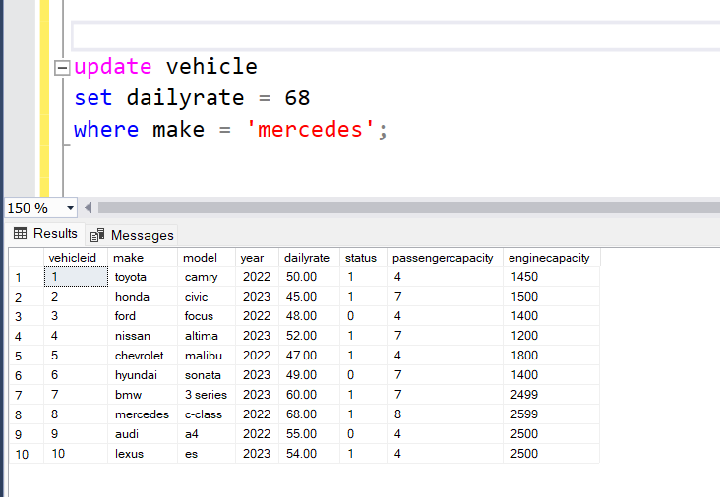

**2. Delete a specific customer and all associated leases and payments.**

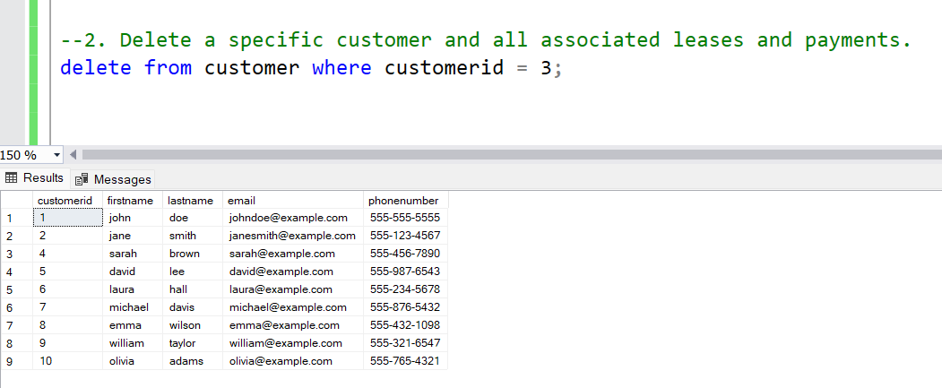

**3. Rename the "paymentDate" column in the Payment table to "transactionDate".**

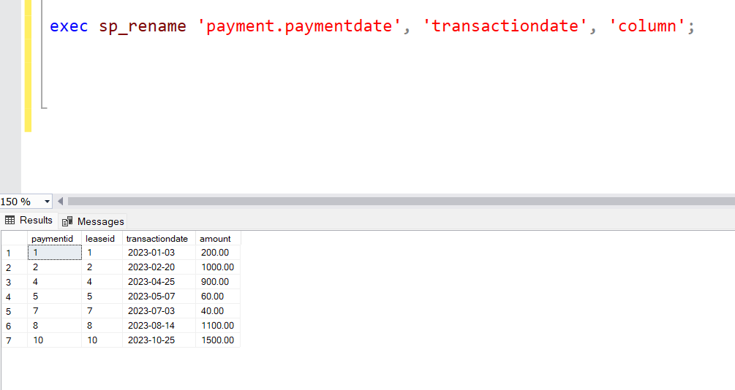

**4. Find a specific customer by email.**

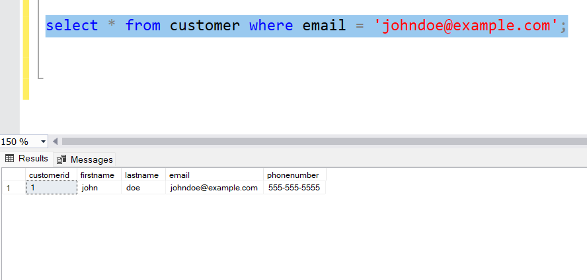

**5. Get active leases for a specific customer.**

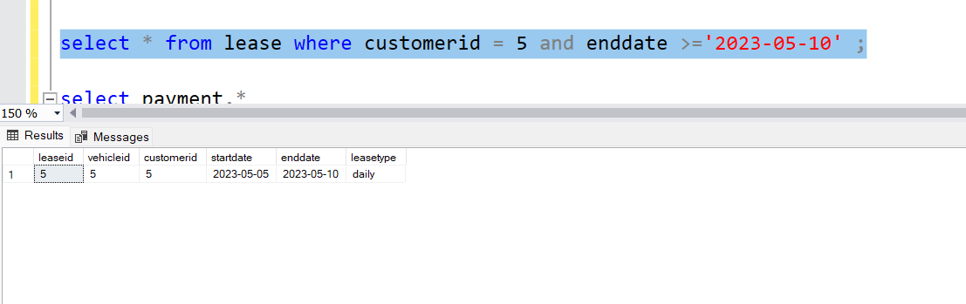

**6. Find all payments made by a customer with a specific phone number.**

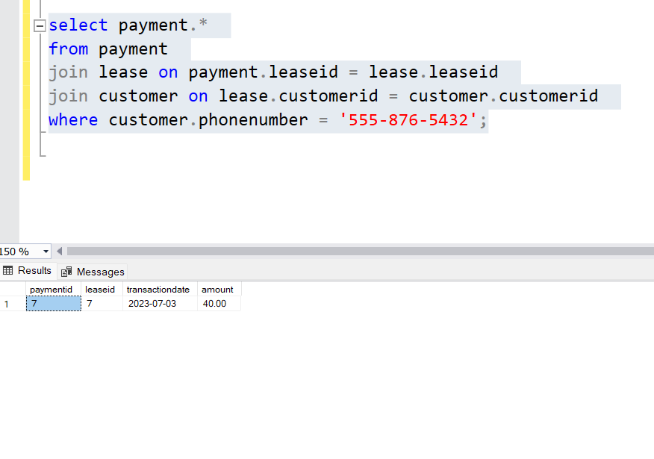

**7. Calculate the average daily rate of all available cars.**

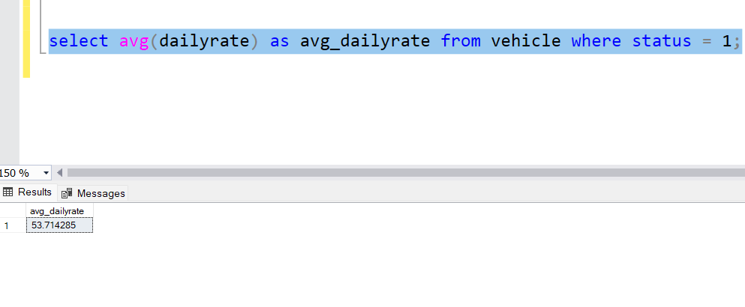

**8. Find the car with the highest daily rate.**

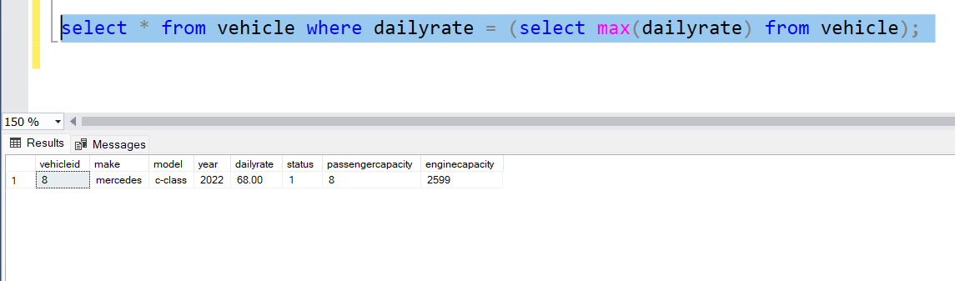

**9. Retrieve all cars leased by a specific customer.**

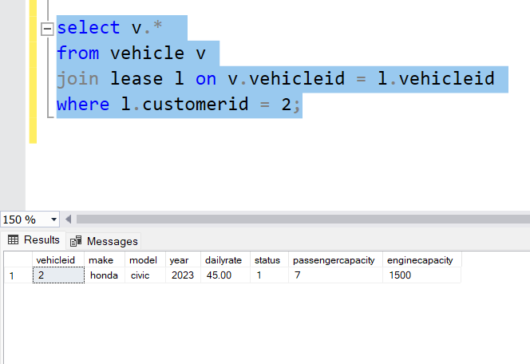

**10. Find the details of the most recent lease.**

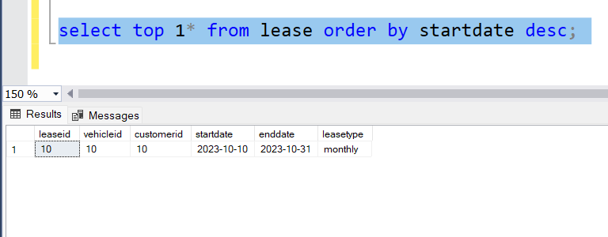

**11. List all payments made in the year 2023.**

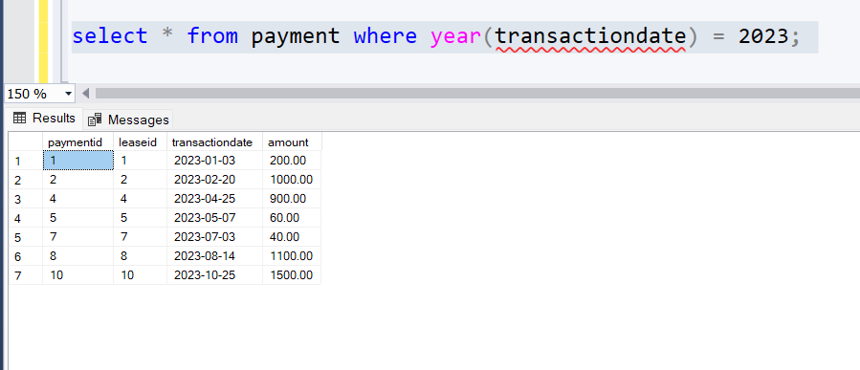

**12. Retrieve customers who have not made any payments.**

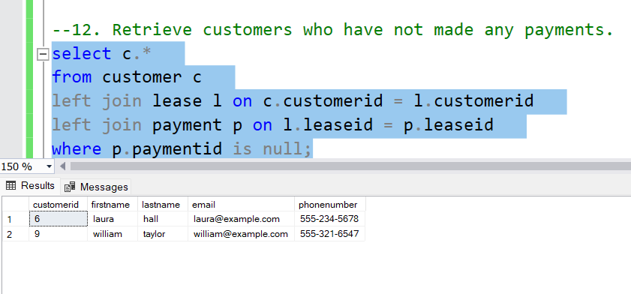

**13. Retrieve Car Details and Their Total Payments.**

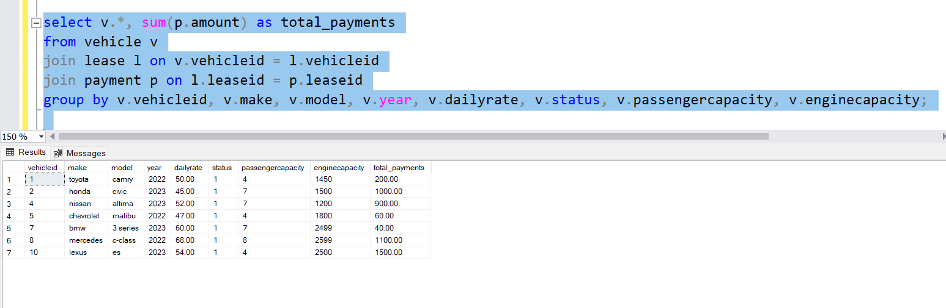

**14. Calculate Total Payments for Each Customer.**

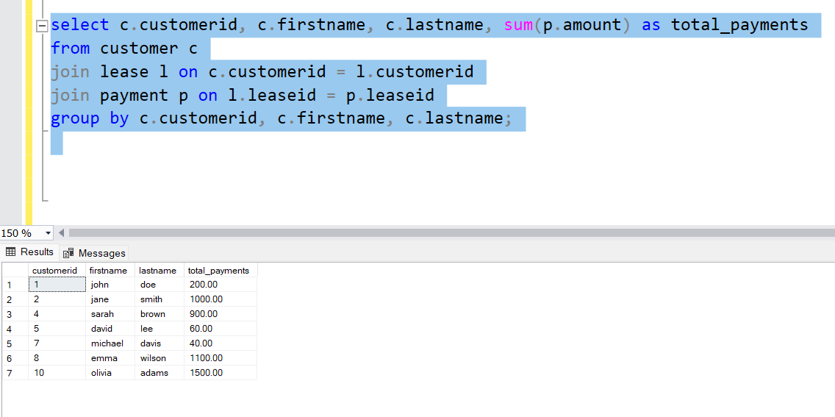

**15. List Car Details for Each Lease.**

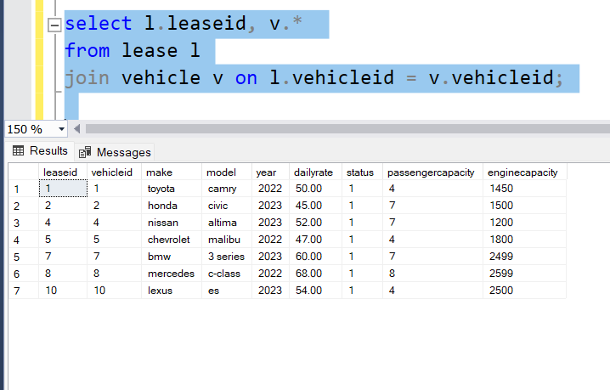

**16. Retrieve Details of Active Leases with Customer and Car Information.**

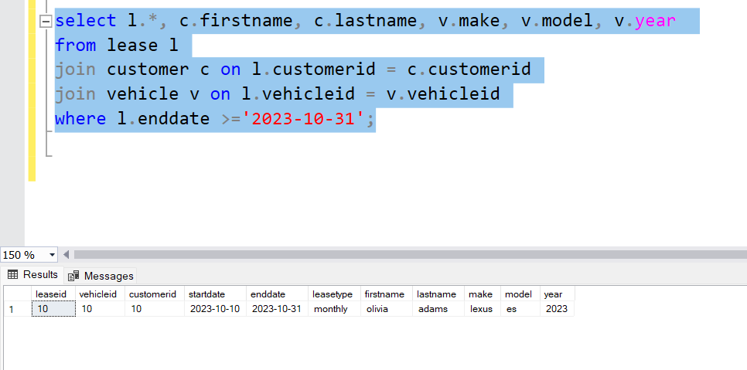

**17. Find the Customer Who Has Spent the Most on Leases.**

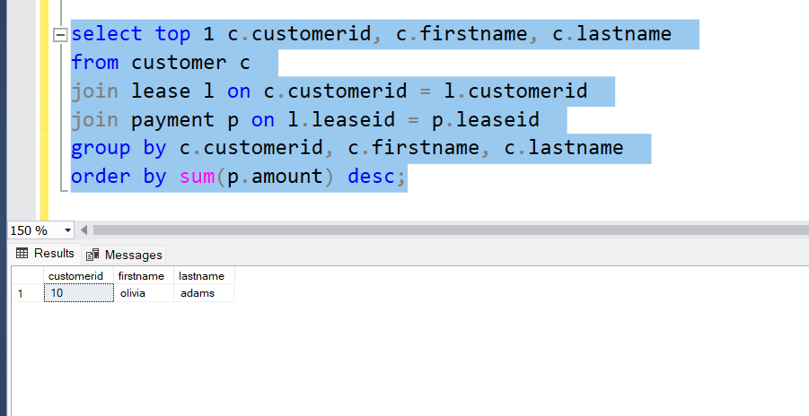

**18. List All Cars with Their Current Lease Information.**

